PHASE 2
REQUIREMENT ANALYSIS

Objective:
To identify and analyze the functional and non-functional requirements of the AI BlogNest system.

Functional Requirements:
- User registration and login.
- Secure user authentication using JWT.
- Create new blog posts.
- View existing blog posts.
- Update blog posts.
- Delete blog posts.
- Generate blog content using Google Gemini AI.
- Summarize blog content using AI.
- Store user and blog information in MongoDB.

Non-Functional Requirements:
- The system should be user-friendly and easy to use.
- User passwords should be securely protected.
- The system should validate user inputs.
- The system should provide proper error messages.
- The application should provide reliable database operations.
- The system should have a modular and maintainable structure.

Software Requirements:
- Visual Studio Code
- Node.js
- MongoDB
- MongoDB Compass
- Postman / Thunder Client
- Web Browser

Expected Output:
A clearly defined list of functional and non-functional requirements required for developing the AI BlogNest system.

Phase Status:
Completed.

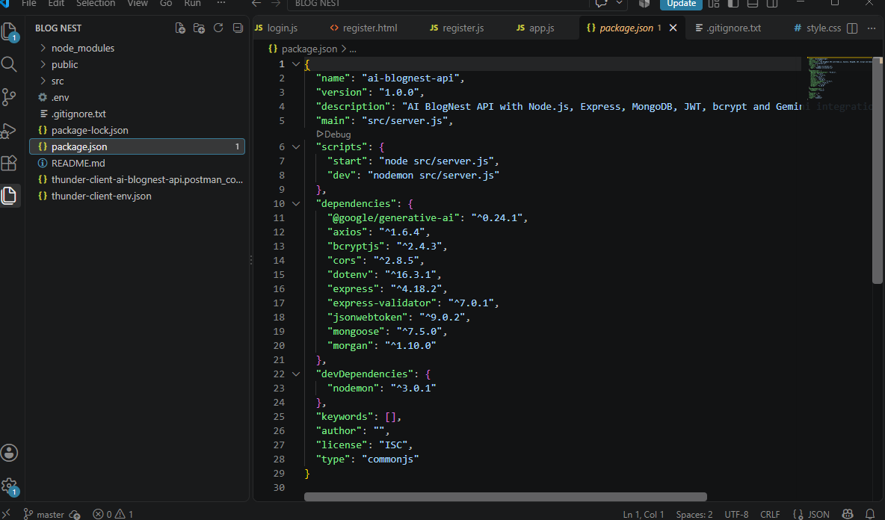
Figure 2.1: Software Requirements and Project Dependencies

